**National University of Computer & Emerging Sciences, Karachi**

**Computer Science Department**

**Fall 2022, Lab Manual - 06**

|  |  |
| --- | --- |
| **Course Code: CL-1004** | **Course : Object Oriented Programming Lab** |
| **Instructor(s) :** | **Shahroz Bakht** |

**Lab # 06**

# Outline:

* Introduction to Inheritance
* Single Level Inheritance
* Visibility Modes
* Multilevel Inheritance
* Hierarchical Inheritance

# INTRODUCTION TO INHERITANCE

Inheritance is one of the key features of Object-oriented programming in C++. It allows us to create a new class (derived class) from an existing class (base class).

## Base Class:

* A base class is the class from which features are to be inherited into another class.

## Derived Class:

* A derived class is the one which inherits features from the base class. It can have additional properties and methods that are not present in the parent class that distinguishes it and provides additional functionality.

## Real World Example:

* A real world example of inheritance constitutes the concept that children inherit certain features and traits from their parents. In addition, children also have their unique features and traits that distinguishes them from their parents.

## Basic syntax for Inheritance:

class derived-class-name : access base-class-name {

// body of class

};

## Advantages of Inheritance:

The main advantage of inheritance is **code reusability**. You can reuse the members of your base class inside the derived class, without having to rewrite the code.

# TYPES OF INHERITANCE BASED ON BASE CLASS ACCESS CONTROL

There are three types of inheritance with respect to base class access control:

* Public
* Private
* Protected

## Public Inheritance:

### With public inheritance, every object of a derived class is also an object of that derived class’s base class. However, base class objects are not objects of their derived classes.

## Is – A Relationship:

* Inheritance is represented by an is-a relationship which means that an object of a derived class also can be treated as an object of its base class for example, a Car is a Vehicle, so any attributes and behaviors of a Vehicle are also attributes and behaviors of a Car.

## Syntax for public Inheritance:

Class (name of the derived class) : public (name of the base class)

Class Car : public Vehicle

## 

## Base Class Access Control for Public, Private and Protected:

|  |  |  |  |
| --- | --- | --- | --- |
| **Visibility of Base Class Members** | **Types of Inheritance** | | |
|  | ***Public Inheritance*** | ***Private Inheritance*** | ***Protected Inheritance*** |
| Public | Public in derived class | Private in derived class | Protected in derived class |
| Private | Hidden in derived class | Hidden in derived class | Hidden in derived class |
| Protected | Protected in derived class | Hidden in derived class | Protected in derived class |

# TYPES OF INHERITANCE BASED ON DERIVED CLASSES

Inheritance based on derived classes can be categorized as follows:

* Single Inheritance
* Multiple Inheritance
* Multilevel Inheritance
* Hierarchical Inheritance
* Hybrid Inheritance

## Single Inheritance:

* In this type of inheritance there is one base class and one derived class.
* As shown in the figure below, in single inheritance only one class can be derived from the base class. Based on the visibility mode used or access specifier used while deriving, the properties of the base class are derived.

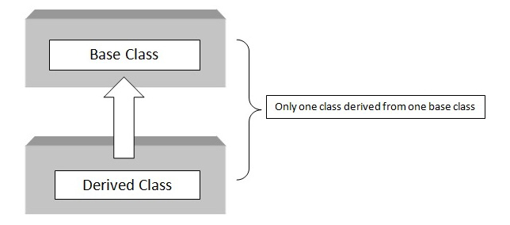

## Syntax for single Inheritance:

C class A // base class

{ {

X // body of the class

}; };

class B : acess_specifier A // derived class

{ {

// body of the class

};

} ;

## Example code for single Inheritance:

#include <iostream>

using namespace std;

class base //single base class

{

public:

int x;

void getdata()

{

cout << "Enter the value of x = "; cin >> x;

}

};

class derive : public base //single derived class

{

private:

int y;

public:

void readdata()

{

cout << "Enter the value of y = "; cin >> y;

}

void product()

{

cout << "Product = " << x * y;

}

};

int main()

{

derive a; //object of derived class

a.getdata();

a.readdata();

a.product();

return 0;

} //end of program

**Sample Run**

Enter the value of x = 3

Enter the value of y = 4

Product = 12

## Multilevel Inheritance:

* If a class is derived from another derived class then it is called multilevel inheritance, so in multilevel inheritance, a class has more than one parent class.
* As shown in the figure below, class C has class B and class A as parent classes.
* As in other inheritance, based on the visibility mode used or access specifier used. while deriving, the properties of the base class are derived. Access specifier can be private, protected or public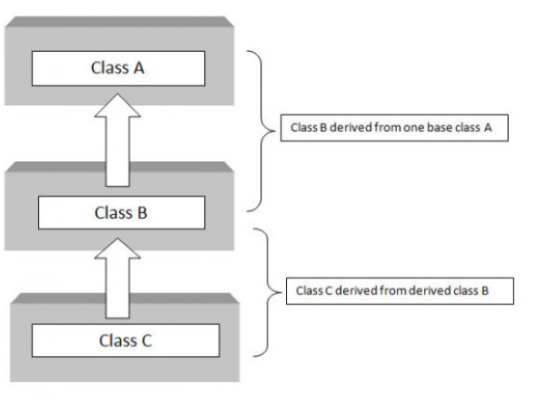.

## Syntax for multilevel Inheritance:

C class A // base class

{

X // body of the class

};

class B : acess_specifier A // derived class

{ {

X // body of the class

}; };

class C : acess_specifier B // derived from class B

{ {

// body of the class

};

} ;

## Example code for multilevel Inheritance:

#include <iostream>

using namespace std;

class base //single base class

{

public:

int x;

void getdata()

{

cout << "Enter value of x= "; cin >> x;

}

};

class derive1 : public base // derived class from base class

{

public:

int y;

void readdata()

{

cout << "\nEnter value of y= "; cin >> y;

}

};

class derive2 : public derive1 // derived from class derive1

{

private:

int z;

public:

void indata()

{

cout << "\nEnter value of z= "; cin >> z;

}

void product()

{

cout << "\nProduct= " << x * y * z;

}

};

int main()

{

derive2 a; //object of derived class

a.getdata();

a.readdata();

a.indata();

a.product();

return 0;

} //end of program

**Sample Run**

Enter value of x= 2

Enter value of y= 3

Enter value of z= 3

Product= 18

## Hierarchical Inheritance:

* When several classes are derived from a common base class it is called as hierarchical inheritance.
* In C++ hierarchical inheritance, the feature of the base class is inherited onto more than one sub-class.
* For example, a car is a common class from which Audi, Ferrari, Maruti etc can be derived.
* As shown in the figure below, in C++ hierarchical inheritance all the derived classes have a common base class. The base class includes all the features that are common to derived classes.

## C:\Users\Administrator\Documents\OOP\Lab Manuals + Tasks\Lab - 8\Hierarchical Inheritance.PNG

## Syntax for hierarchical Inheritance:

C class A // base class

{

X // body of the class

};

class B : acess_specifier A // derived class from A

{ {

X // body of the class

}; };

class C : acess_specifier A // derived class from A

{ {

// body of the class

};

} ; class D : acess_specifier A // derived class from A

{ {

// body of the class

};

## Example code for hierarchical Inheritance:

#include <iostream>

using namespace std;

class A //single base class

{

public:

int x, y;

void getdata()

{

cout << "\n Enter value of x and y:\n"; cin >> x >> y;

}

};

class B : public A //B is derived from class base

{

public:

void product()

{

cout << "\n Product= " << x * y;

}

};

class C : public A //C is also derived from class base

{

public:

void sum()

{

cout << "\n Sum= " << x + y;

}

};

int main()

{

B obj1; //object of derived class B

C obj2; //object of derived class C

obj1.getdata();

obj1.product();

obj2.getdata();

obj2.sum();

return 0;

} //end of program

**Sample Run**

Enter value of x and y:

2

3

Product= 6

Enter value of x and y:

2

3

Sum= 5

# LAB ACTIVITIES

**Task # 01**

Create a base class called shape. Use this class to store two double type values that could be used to compute the area of figures. Derive two specific classes called triangle and rectangle from the base shape. Add to the base class, a member function get_data( ) to initialize base class data members and another member function display_area( ) to compute and display the area of figures. Make display_area ( ) as a virtual function and redefine this function in the derived classes to suit their requirements. Using these three classes, design a program that will accept dimensions of a triangle or a rectangle interactively and display the area. Remember the two values given as input will be treated as lengths of two sides in the case of rectangles and as base and height in the case of triangles and used as follows:

**Area of rectangle = x * y**

**Area of triangle = ½ * x * y**

**Task # 02**

Design a class Point with two data members x-cord and y-cord. This class should have an arguments constructor, setters, getters and a display function. Now create another class “Line”, which contains two Points “startPoint” and “endPoint”. It should have a function that finds the length of the line.

**Hint: formula is: sqrt((x2-x1)2 + (y2-y1)2)**

Create two line objects and display the length of each line.

**Task # 03**

We want to calculate the total marks of each student of a class in Physics, Chemistry and Mathematics and the average marks of the class. The number of students in the class are entered by the user. Create a class named **Marks** with private data members

* roll number
* name
* marks

Create three other classes inheriting the Marks class, namely

* Physics
* Chemistry
* Mathematics

which are used to define marks in individual subject of each student. Roll number of each student will be generated automatically.

**Task # 04**

Create a class **Number** that contains the following attributes and methods.

1. - Number
2. + getNumber()
3. + returnNumber()

Derive two classes from class Number namely,

1. SquareOfNumber
2. CubeOfNumber

Write appropriate functions in the class **Square** and **Cube** to calculate the square and cube of any given number.

**Task # 05**

Consider a base class named **Employee** and its derived classes **HourlyEmployee** and **PermanentEmployee** while taking into account the following criteria.

* Employee class has two data fields i.e**. name (type of string)** and **empID (of type integer)**.
* Both classes **(HourlyEmployee and PermanentEmployee)** have an attribute named **hourlyIncome.**
* Both classes (**HourlyEmployee and PermanentEmployee**) have three argument constructor to initialize the **hourlyIncome** as well as data fields of the base class.
* Class **HourlyEmployee** has a function named **calculate_hourly_income** to calculate the income of an employee for the actual number of hours he or she worked. One-hour income is Rs.150.
* Similarly, **PermanentEmployee** class has the function named **calculate_income** to calculate the income of an employee that gets paid the salary for exact 240 hours, no matter how many actual hours he or she worked. Again, one hour is Rs 150.

Implement all class definition with their respective constructors to initialize all data members and functions to compute the total income of an employee. In the **main()** function, create an instance of both classes (i.e. **HourlyEmployee and PermanentEmployee**) and test the working of functions that calculate the total income of an employee.

**Task # 06**

Consider a class **BankAccount** that has:

* Two attributes i.e. **accountID** and balance
* A functions named **balanceInquiry()** to get information about the current amount in the account.

Derive two classes from the **BankAccount** class i.e. **CurrentAccount** and **SavingAccount**. Both classes inherit all the attributes and behaviors from the **BankAccount** class. In addition, followings are required to be the part of both classes:

* Appropriate constructors to initialize data fields of base class
* A function named **amountWithdraw(amount)** to withdraw certain amount while taken into account the following conditions
  + While withdrawing from current account, the minimum balance should not decrease Rs. 5000
  + While withdrawing from saving account, the minimum balance should not decrease Rs. 10,000
* **amoutDeposit(amount)** to deposit amount in the account.

In main () function, create instance of derived class (i.e. **CurrentAccount** and **SavingAccounts**) and invoke their respective functions to test their working.